Demonstration Links:

* Code Injected Directly into the Web Part Page:

<https://bentest.bhcorp.ad/sites/regulatory3/Pages/MenuTest.aspx?PageView=Shared&InitialTabId=Ribbon.WebPartPage&VisibilityContext=WSSWebPartPage>

* Code Referenced in the Web Part Page:

<https://bentest.bhcorp.ad/sites/regulatory3/Pages/MenuTest3.aspx?PageView=Shared&InitialTabId=Ribbon.WebPartPage&VisibilityContext=WSSWebPartPage>

* Code Referenced in a Master Page:

<https://bentest.bhcorp.ad/sites/regulatory3/testmenu4/Pages/default.aspx>

* Navigation List:

<https://bentest.bhcorp.ad/sites/regulatory3/Lists/Navigation/AllItems.aspx>

1. Overview: The purpose of this document is to provide a technical overview of the SharePoint Regulatory Site Accordion Menu Solution (short name Accordion Menu).
2. High Level Accordion Menu Features:
   1. Two Level Collapsible Quick Launch Menu
   2. Deployed by a Custom Master Page
   3. Can be Deployed at Site Collection, Site, or a Mixed Level
   4. Configured by a Custom List
   5. Custom List has Custom Forms
   6. Custom List Forms have User Instructions
   7. Custom List Forms have Custom Field Validation
   8. Menu Item Content is User Customizable
   9. Menu Item Level is User Customizable
   10. Menu Item Sequence is User Customizable
   11. Menu Item Link is User Customizable
   12. Menu Item Security is User Customizable
3. Basic Level Code Extension Categories:
   1. Menu Style
   2. “Universal” Menu Items\Links
   3. Form Instructions
   4. Form Validation Error Messages
4. Accordion Menu Solution Components:
   1. Custom Content Type – Regulatory Accordion Menu
   2. Custom Accordion Menu List New Form
      1. Custom Layout – MenuNewForm.aspx
      2. Custom Validation Code – MenuNewFormValidation.js
      3. Custom User Help – MenuNewForm.jpg
   3. Custom Accordion Menu Edit Form
      1. Custom Layout – MenuEditForm.asp
      2. Custom Validation Code – MenuEditFormValidation.js
      3. Custom User Help – MenuEditForm.jpg
   4. Custom Accordion Menu Navigation Code
      1. Custom REST API Code – MenuRESTAPI.js
      2. Custom Dynamic CSS Code – MenuDynamicCSS.js
      3. Custom CSS Code – MenuCSS.css
      4. Custom HTML – MenuHTML.html
   5. Custom Accordion Menu MasterPage – MenuMaster.master
   6. Custom Quick Launch Navigation Configuration
   7. User’s Guide
   8. Administrator’s Guide
5. Custom Content Type – Regulatory Accordion Menu
   1. Title – Single Line of Text
   2. Link – Single Line of Text
   3. Level – Choice
   4. Level 1 Sequence – Choice
   5. Level 2 Sequence – Choice
   6. Top Item ID
6. Custom Accordion Menu List New Form
   1. Purpose: Create New Menu Items for the Accordion Menu
   2. Features:
      1. Custom List Form

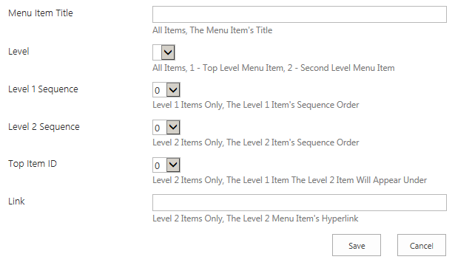

* + 1. Custom User Help Image

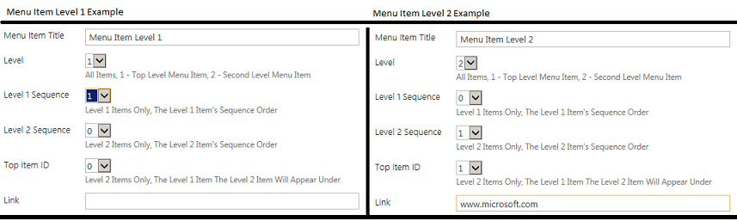

* + 1. Link to User’s Guide



* + 1. Custom Validation Code (Stored in Development Team Docs):

<https://ben.blackhillscorp.com/sites/Regulatory/Development%20Team%20Docs/NewFormD.js>

1. Custom Accordion Menu Edit Form
   1. Purpose: Edit Existing Menu Items for the Accordion Menu
   2. Features:
      1. Custom List Form

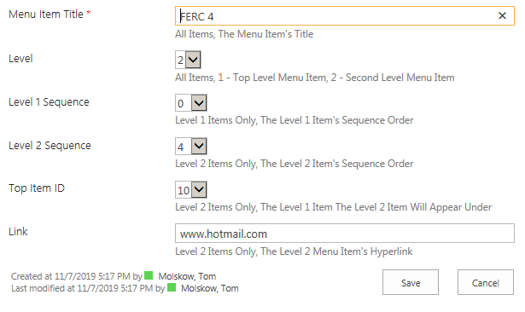

* + 1. Custom User Help Image



* + 1. Link to User’s Guide



* + 1. Custom Validation Code (Stored in Development Team Docs):

<https://ben.blackhillscorp.com/sites/Regulatory/Development%20Team%20Docs/NewFormD.js>

1. Custom Accordion Menu Navigation Code
   1. Purpose: Displays Menu Items Dynamically
   2. Features:
      1. Custom REST API Code (Stored in Development Team Docs):

<https://ben.blackhillscorp.com/sites/Regulatory/SiteAssets/Menu/RESTAPID.js>

* + 1. Custom Dynamic CSS Code (Stored in Development Team Docs):

<https://ben.blackhillscorp.com/sites/Regulatory/SiteAssets/Menu/DynamicCSSD.js>

* + 1. Custom CSS Code (Stored in Development Team Docs):

<https://ben.blackhillscorp.com/sites/Regulatory/SiteAssets/Menu/ConsolidatedCSS.css>

* + 1. Custom HTML Div (Stored in Development Team Docs):

<https://ben.blackhillscorp.com/sites/Regulatory/SiteAssets/Menu/HTML.html>

1. Custom Accordion Menu MasterPage – Menu.Master
   1. Purpose: Container for Accordion Menu Navigation Code
   2. Features:
      1. Custom REST API Code Injection Point
      2. Custom Dynamic CSS Code Injection Point
      3. Custom CSS Code Injection Point
      4. Custom HTML Div Injection Point
   3. Enable the Menu.Master Master Page
      1. Click on the Site Settings Cog and from the Drop-Down Menu Choose “Site Settings”
      2. From Site Settings, Under the “Look and Feel” Header Choose “Master Page”
      3. In the “Site Master Page” Section:
         1. Choose “Specify a master page to be used by this site and all sites that inherit from it:”
         2. From the Drop Down Choose “Menu”
         3. Check “Reset all subsites to inherit this site master page setting”
      4. In the “System Master Page” Section:
         1. Choose “Specify a system master page for this site and all sites that inherit from it:”
         2. From the Drop Down Choose “Menu”
         3. Check “Reset all subsites to inherit this system master page setting”
      5. Scroll Down and Click on the “OK” Button
2. Custom Quick Launch Navigation Configuration
   1. Purpose: Removes Any OOTB Quick Launch Links
   2. Configuration Steps:
      1. Click on the Site Settings Cog and from the Drop-Down Menu Choose “Site Settings”
      2. From Site Settings, Under the “Look and Feel” Header Choose “Navigation”
      3. Scroll Down to the Current Navigation and Take these Actions:
         1. Choose “Structural Navigation: Display only the navigation items below the current site”
         2. Uncheck “Show subsites”
         3. Uncheck “Show pages”
      4. Finally Scroll Down and Click the “OK” Button